Process and Procedure Names:  - Process: IT Management Operating System  - Procedure: HUE within IT Waterfall/Agile Projects | Work Instruction Name:  Personas | Effective Date: 20-Mar-2017
Work Instruction Owner:  Madhumita Gupta | Work Instruction Name:  Personas | Revision Date: 08-Dec-2017

Purpose

The purpose of personas is to create reliable and realistic representations of your key audience segments for reference. These representations should be based on qualitative and some quantitative user research and analytics. HUE training is a prerequisite: Persona and Scenarios training – only focus on Persona part of training. There is also a Persona Creation
Playbook available.

Scope

This work instruction is for creating personas relevant to the site/application.

Work Instruction Activities

Step # | Description | Owner (Role) | Details (e.g. screenshots, charts, etc.)
 | Based on stakeholder mapping, review the HON standard personas and see to what degree they sufficiently convey knowledge about users that is required for the project. | HUE Representative | Refer to Work Instruction:  - “Stakeholder Mapping”  Refer to the HON standard personas:  The 8 HON Employee personas:  - Anna – Assistant  - Tina – Team Manager  - Ellen – Executive  - Avi – Engineer  - Li Min – Human Resources  - Frank – Finance/Procurement  - Adela – Front Line Worker  - Glen - Remote Worker  The 4 Key Enabler personas:  - Karen – VPD  - Jose – Commercial Excellence  - Mark – Customer Support  - Francesca - Procurement
 | If additional knowledge is needed, conduct user research using (O)VOC, surveys to gather information on –  - Who are your users?  - Why are they using the system?  - What behaviors, assumptions, and expectations color their view of the system? | HUE Representative | Refer to Work Instructions:  - “Interviews”  - “Field Observations”  - “Surveys”
 | Condense the research by looking for themes/characteristics that are specific, relevant, and universal to the system and its users. Finally organize elements into persona groups that represent your target users. Name or classify each group. | HUE Representative
 | Combine and prioritize the rough personas. Separate them into primary, secondary, and, if necessary, complementary categories. You should have roughly 3-5 personas and their identified characteristics. | HUE Representative
 | Develop the appropriate descriptions of each personas background, motivations, and expectations. Do not include a lot of personal information. Be relevant and serious; humor is not appropriate. | HUE Representative | Minimum set of descriptors for a persona:  - Fictional name (first name)  - Portrait photo of the persona  - Mindset (memorable quote, summarizing how the persona ticks)  - Needs & Goals (desires, wishes, expectations, aspirations, etc.)  - Distinctive Characteristics (age, income, education, etc.)  Feel free to use the Persona template.
 | Ensure that your personas can be mapped to the standard Honeywell personas. | HUE Representative | The 8 HON Employee personas:  - Anna – Assistant  - Tina – Team Manager  - Ellen – Executive  - Avi – Engineer  - Li Min – Human Resources  - Frank – Finance/Procurement  - Adela – Front Line Worker  - Glen - Remote Worker  The 4 Key Enabler personas:  - Karen – VPD  - Jose – Commercial Excellence  - Mark – Customer Support  - Francesca - Procurement
 | Present personas for reference to stakeholders, designers and developers | HUE Representative | 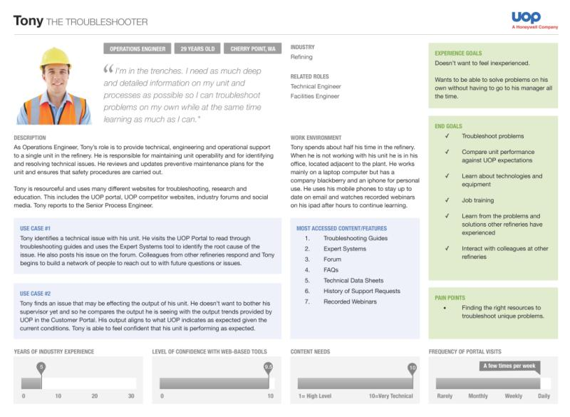
6. | Store electronic version of the personas as project artefacts on project share drive | HUE Representative

Enforcement

Failure to adhere to published policies, processes, procedures, work instructions and standards will be evaluated on a case by case basis and may result in disciplinary action. Published policies, processes, procedures, work instructions and standards are also subject to audit by Honeywell Corporate Audit and external auditors for verification of compliance.

Version Control and Review Frequency

This Procedure is to be reviewed at minimum annually.

Date Last Reviewed: 08-Dec-2017
Reviewed By: Tobias Komischke, IT HUE Leader

Version # | Effective Date | Section(s) | Description | Author | Content/SME  Approval | Work Instruction Owner Approval
1.0 | 20-Mar-2017 | Full document | First version | Madhumita Gupta | Tobias Komischke | Tobias Komischke
1.1 | 30-Jun-2017 | “Work Instruction Activities” Section | Added links to the HON Standard Personas | Tobias Komischke | Madhumita Gupta | Tobias Komischke
2.0 | 01-Nov-2017 | All | Incorporated new role of HUE representative and aligned to approved HUE process integration with waterfall/agile Software process | Madhumita Gupta | Tobias Komischke | Tobias Komischke
2.1 | 08-Dec-2017 | All | Formatting edits based on Process Change Register requests | Tobias Komischke | Madhumita Gupta | Tobias Komischke
*Process Owner, Process Governance and External Compliance approvals are through the automated tool

